GRANT APPLICATION FORM  Last Updated 03/17  A full list of our grant-making criteria is enclosed. Please consult this prior to completing this application form.  Please complete this form clearly.  For our Data Protection Policy please see attached sheet. | 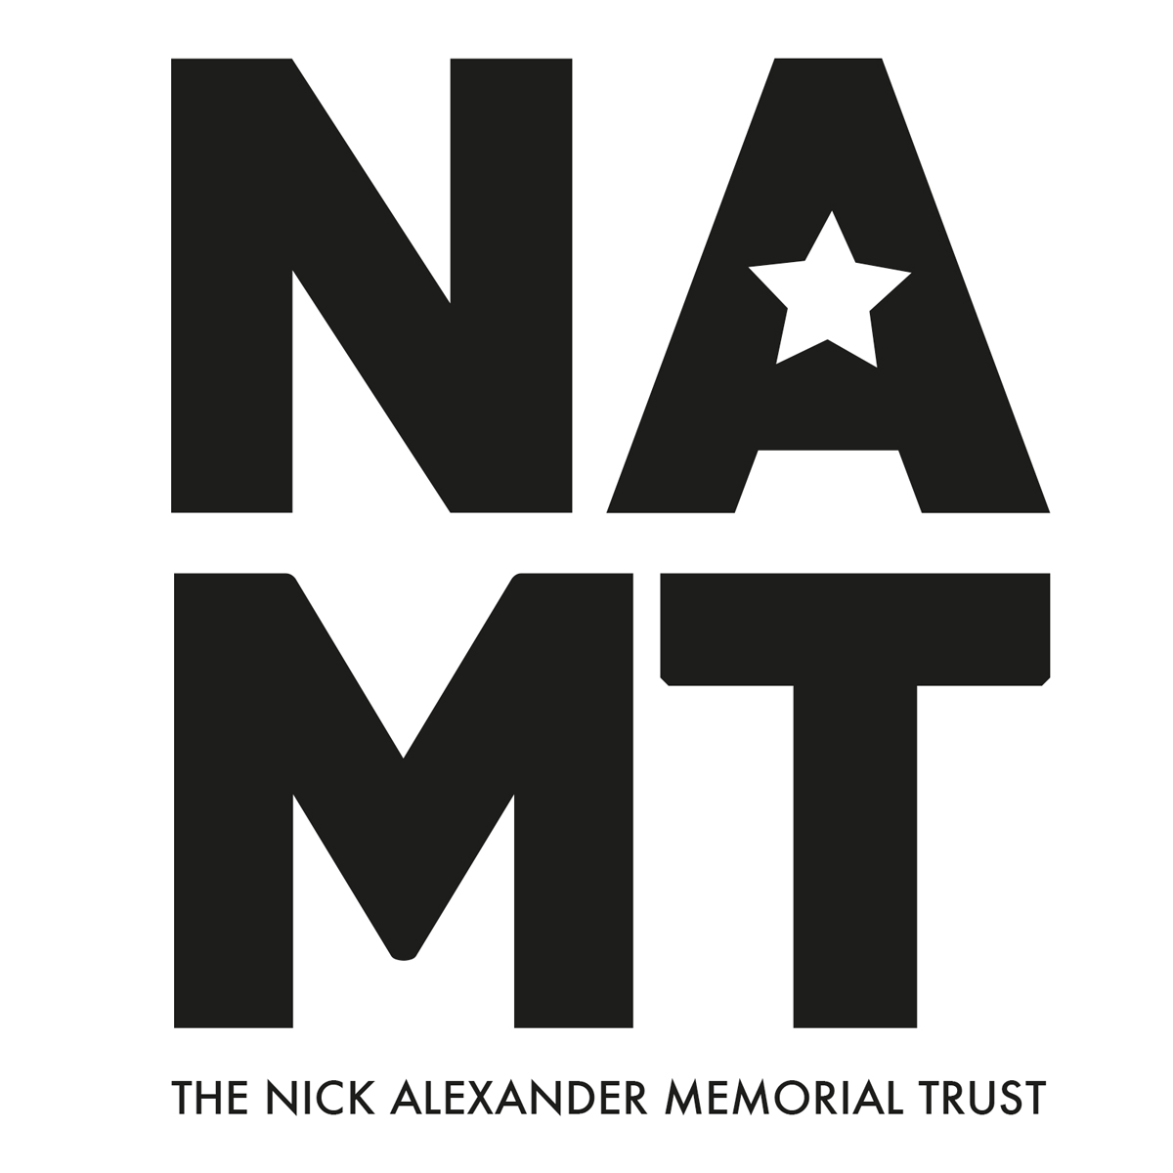

YOUR DETAILS

Organisation Name:

Registered Address:

Registered Charity Number (if applicable):

Website:

Contact Address (if different):

Contact Name: Contact Tel:

Contact email:

YOUR ORGANISATION

What is the purpose of your organisation?

What local areas does the organisation work in?

Who are the main beneficiaries of the organisation’s work? (please circle as appropriate)
Financially Disadvantaged / Young People / Ethnic Minorities / Disability or illness/ Older People/ Homeless People
Other (please specify):

GRANT REQUEST DETAILS:

Total Amount Requested: (please specify amount in GBP rounded up to the nearest pound)

Please provide a breakdown of instruments/equipment required and the purchase cost
Continue on a separate sheet if required.
ITEM | COST

Have you attached quotations for the items? YES/NO

Please provide a description of the activities/projects that would be delivered with a grant:

How many people do you estimate will benefit from this grant?

How will this benefit the organisation’s members and the wider community?

ADDITIONAL INFORMATION:

In line with our registration with the Charities Commission we reserve the right to visit the organisation to see any equipment purchased at a mutually convenient time. Will you be happy to facilitate this? YES/NO

If not, please outline reasons below:

In the event that your grant is successful will you be happy to provide The Nick Alexander Memorial Trust with pictures of the equipment in use for use on our website and promotional literature? YES/NO

Is this your first application to The Nick Alexander Memorial Trust? YES/NO
If No please give details of previous application(s):

How did you hear about The Nick Alexander Memorial Trust?

Signed:

Dated:

Please return completed applications by post or email to:
The Nick Alexander Memorial Trust,
Fairfield,
Clacton Road,
Weeley.
Essex CO16 9DN
info@thenickalexandermemorialtrust.com
PLEASE NOTE: Applicants should not assume that submission of this form implies that a grant will be awarded. We regret that if you do not hear from us within 3 months of the date of application you should assume that your application has not been successful.

